April Milam

CS-255-System Analysis and Design

Assignment Three

March 23, 2024

Describe Hamp Craft’s current purchase and supply process by interpreting the provided data flow diagram. What does it show and what does the current purchase and supply process entail? What are the data sources involved in the current process?

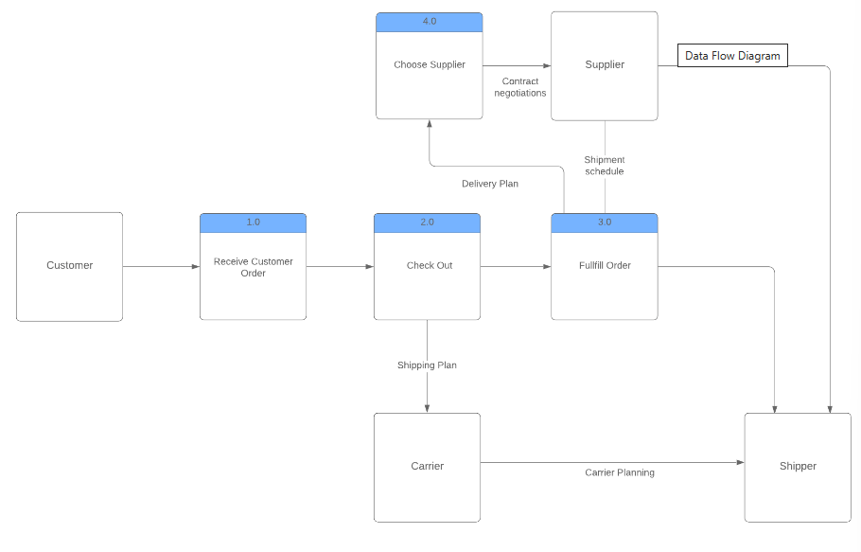

**Process**

1. Receive Customer Order
2. Check Out
3. Fullfill Order
4. Choose Supplier

**Source/Sink**

* Customer
* Carrier
* Supplier
* Shipper

**Data Flow**

1. Capturing data from the customer and process orders (Process 1.0)
2. Check out is the process of taking payment and shipping plan to carrier (Process 2.0, sink shipping plan to carrier)
3. Carrier with the shipping plan to carrier planning (sink)
4. Fulfilling orders and distributing to the which delivery Plan and shipment schedule (Process 3.0 and data flow and sink)
5. Choose Supplier which has delivery plan flowed into it and contract negotiations (Process 3.0, Process 4.0, and Sink)
6. Supplier having the contract negotiations to shipper (sink flow to sink)

* **What are the current purchases and supply process that Hamp Craft’s need in additional requirements for online storefront?**
* **What additional processes are necessary to integrate an online storefront?**
* **What additional data sources would the system need to access the products and inventory?**
* **What additional databases, if any, are needed to support the online storefront?**

One additional process would be to have inventory management to show them on hands and subtract the online purchase as well as the in-store purchases. Depending on the product there could be online purchases and in-store pick-up as an option to help reduce the cost to the customer and provide additional purchases without having to pay for the shipping cost. Adding these options for customer accounts and payments in a website and/or app allows them to save their sitting or find similar items. Tracking of the shipments and providing online in-store pick-up gives the customer the choice of how they would like to get their product either by delivery or by picking up in the store.

**Added Processes Needed**

* Customer logon account
* Payment processed.
* Inventory management.
* Payments deposited into company account.
* Shipping Status
* Online Pick Up Status

**New Data Stores**

* Option to save customers’ payment.
* Credentials for the customer’s account.
* Local in store pick up.

**New Data Flows**

* Customer account credentials
* Order that are invalid
* Information of payment
* Deposit of payment
* Shipment tracking
* In store pick up

The store website would have the customer logon account process which would flow into the customer account credentials where the data would be stored and allow a customer to have an account. This would allow them to see the previous purchases and all of them to browse the website for similar items.

The payment process would allow the customer to pay online and have the option to save the payment process. Having this option can also allow the customer to make faster payments and deposit them faster for the company.

Having the compatibility to see if there is an option for in-store pick will provide faster payments and in cuts the shipping out for the customer. Also, this would allow the customer to see if the item is in stock or not. Having these options will increase the business revenue during promotions because the customer has the option to buy online and pick up in store when they would not be able to prior.

**Would you recommend creating a separate new system for the online storefront or incorporating elements of the online storefront into the current process model?**

Editing the current version would make it easier to help incorporate things that were missing from the prior one and adding things that may have been missed. Sometimes having a rough draft of the first model helps determine what needs to be added and what does not fit the needs of the customer. This would also allow for a new version of the data process flow and get a bigger picture of what the client wants.